User Guide – Connecting to other Regional VPN Gateways
1.Launch Cisco Anyconnect application from the taskbar
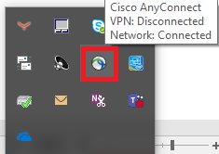
2.Click on the wheel symbol at the bottom to open the Cisco Anyconnect settings
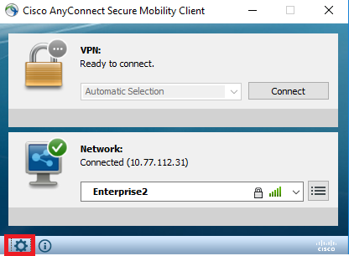
3.On the left-hand side click on VPN and go to preferences tab
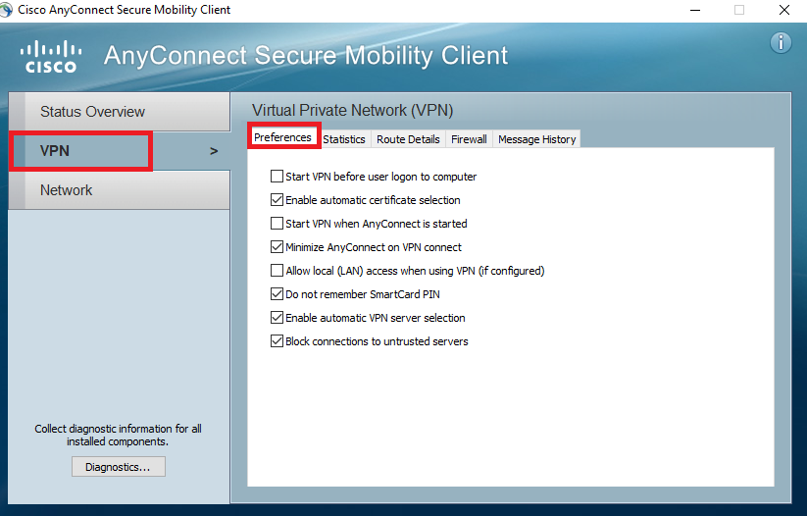
4.Uncheck the option “Enable automatic VPN server selection” and close the settings window
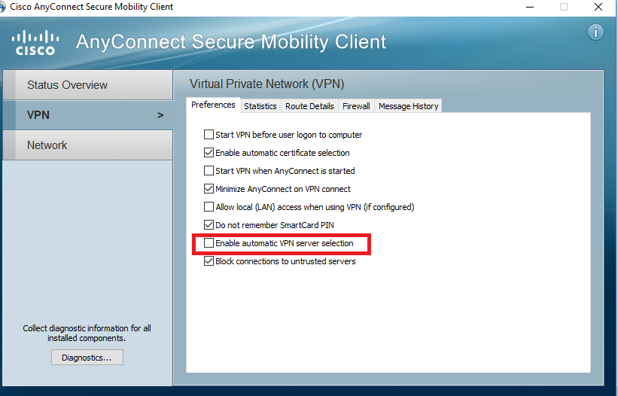

5.Now you will have the option to select other regional VPN gateways
