User Guide – VPN Global Profile Configuration update
Installation from Microsoft Software center
1.Open “Software Center” from your laptop
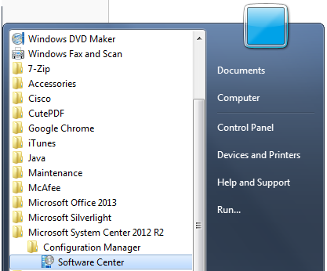
2.To select the VPN profile configuration update “Cisco-Anyconnect_Global_Profile” package by entering “Cisco” in the top right-hand SEARCH bar, and click “INSTALL SELECTED” button to start installation.
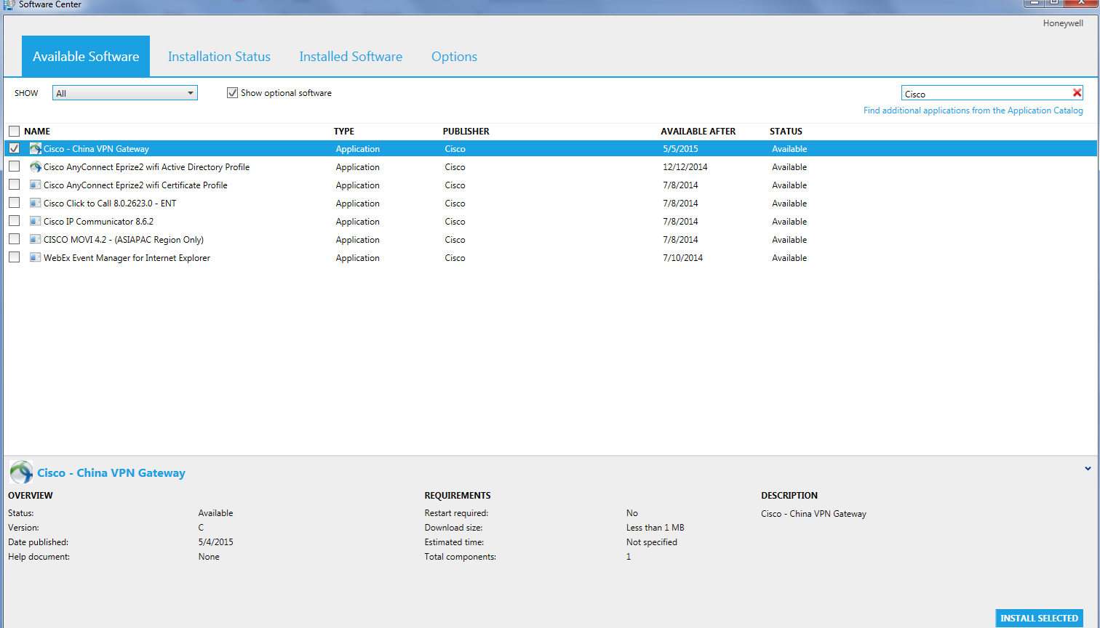
3.You will be given pop-up windows after the installation for a reboot
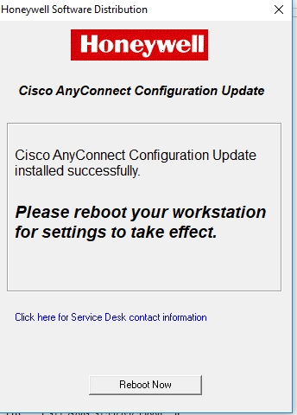

Installation from HRA Website

1.Goto https://www.honeywell.com/hra/downloads
2.Click on the profile “Cisco-Anyconnect_Global_Profile” and save it to the desktop. Unzip/Extract the file to your desktop
3.Right click on the file SWD-Cisco-Anyconnect_Global_Profile.exe and click on “Run as administrator”
4. Once the installation is completed you will get a prompt to reboot the machine

